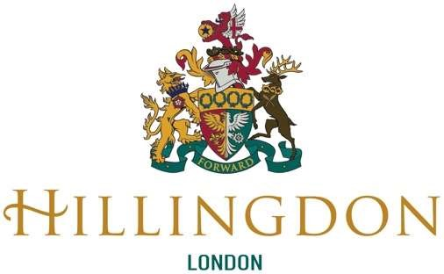
The Silver Fox Memory Group

Ref: IE/rt

February 2022

Dear The Silver Fox Memory Group

Hillingdon Community Awards

You were recently nominated for this year’s Hillingdon Community Awards, which celebrates the work of unsung heroes in Hillingdon.

We have been overwhelmed with the number of nominations we received and greatly moved by the fantastic work that is being undertaken by volunteers and members of the community in Hillingdon.

Following a shortlisting exercise, I am delighted to announce that you have been selected as one of our winners. You have been awarded Gold for the Helping Vulnerable People Award category.

I wanted to personally congratulate you and take this opportunity to express my sincere thanks to you on behalf of the Borough and its residents for the dedication you have shown. It is evident by your award nomination that your work is appreciated by your friends and community.

I will be in touch again soon to invite you to join me at an awards ceremony accompanied by the Mayor of Hillingdon and other winners of this year’s awards.

With my very best wishes

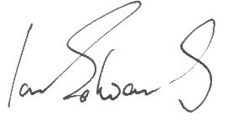
Cllr Ian Edwards
Leader of the Council
 leader@hillingdon.gov.uk
 01895 250316

Conservative Group Office
Phase II, Civic Centre, High Street, Uxbridge, UB8 1UW www.hillingdon.gov.uk
@hillingdon

